Archaic Diction

🕰️ What is Archaic Diction
# Source: Chatgpt (GPT-4-turbo) at [7/30/2025]
Archaic diction refers to the use of old-fashioned, outdated, or obsolete words and expressions that were once common but are rarely used in modern speech or writing—except for stylistic or historical effect.

✅ Key Features:
# Source: Chatgpt (GPT-4-turbo) at [7/30/2025]
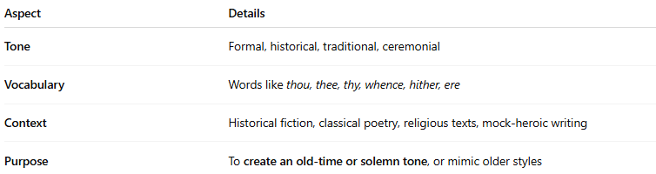
Aspect | Details
Tone | Formal, historical, traditional, ceremonial
Vocabulary | Words like thou, thee, thy, whence, hither, ere
Context | Historical fiction, classical poetry, religious texts, mock-heroic writing
Purpose | To create an old-time or solemn tone, or mimic older styles

🧠 Examples of Archaic Words and Meanings:
# Source: Chatgpt (GPT-4-turbo) at [7/30/2025]
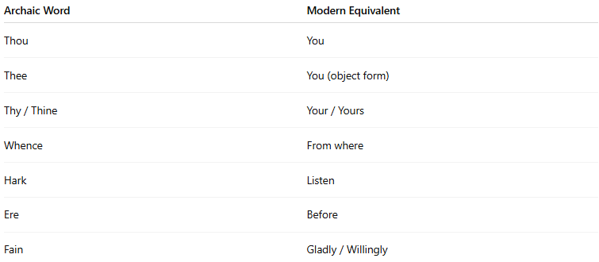
Archaic Word | Modern Equivalent
Thou | You
Thee | You (object form)
Thy / Thine | Your / Yours
Whence | From where
Hark | Listen
Ere | Before
Fain | Gladly / Willingly

✍️ Example Sentences Using Archaic Diction:
# Source: Chatgpt (GPT-4-turbo) at [7/30/2025]
- “Thou art the fairest maiden in the land.”
- “Hark! The herald angels sing.”
- “He would fain leave this place ere nightfall.”

🔍 Archaic vs Poetic Diction:
# Source: Chatgpt (GPT-4-turbo) at [7/30/2025]
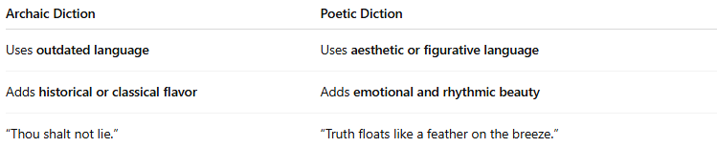
Archaic Diction | Poetic Diction
Uses outdated language | Uses aesthetic or figurative language
Adds historical or classical flavor | Adds emotional and rhythmic beauty
“Thou shalt not lie.” | “Truth floats like a feather on the breeze.”

🧭 Used In:
# Source: Chatgpt (GPT-4-turbo) at [7/30/2025]
- Shakespearean drama and sonnets
- Religious scripture (e.g., King James Bible)
- Historical novels
- Fantasy writing or epics
- Ceremonial or formal speeches

